# A Gesture-Based Tool for Sterile Browsing of Radiology Images

# CNN and Open CV

# **Introduction:**

Humans can recognize body and sign language easily. This is possible due to the combination of vision and synaptic interactions that were formed along brain development. In order to replicate this skill in computers, some problems need to be solved: how to separate objects of interest in images and which image capture technology and classification technique are more appropriate, amongothers.

In this project Gesture based Desktop automation, First the model is trained pre trained on the images of different hand gestures, such as a showing numbers with fingers as 1,2,3,4. This model uses the integrated webcam to capture the video frame. The image of the gesture captured in the video frame is compared with the Pre-trained model and the gesture is identified. If the gesture predicts is 0 - then images is converted into rectangle, 1 - image is Resized into (200,200), 2 - image is rotated by -45॰, 3 - image is blurred, 4 - image is Resized into (400,400), 5 - image is converted into grayscale etc.

# Project Objectives

* Know fundamental concepts and techniques of Convolutional Neural Network(CNN).
* Gain a broad understanding of imagedata.
* Know how to pre-process/clean the data using different data pre- processingtechniques.
* Know how to build a web application using Flaskframework.

# Technical Architecture:

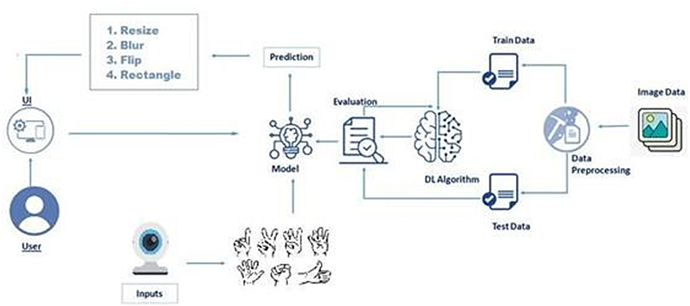

**Overview:**

* Defining our classificationcategories
* Collect trainingimages
* Train themodel
* Test our model

# Project Flow

* User interacts with the UI (User Interface) to upload the image as input.
* Depending on the different gesture inputs different operations are applied to the inputimage.
* Once model analyses the gesture, the prediction with operationapplied on image is showcased on theUI.

To accomplish this, we have to complete all the activities and tasks listed below:

1. DataCollection.
   1. Collect the dataset or Create thedataset
2. Data Preprocessing
   1. Import the ImageDataGeneratorlibrary
   2. Configure ImageDataGeneratorclass
   3. Apply ImageDataGenerator functionality to Trainset andTestset
3. ModelBuilding
   1. Import the model buildingLibraries
   2. Initializing themodel
   3. Adding InputLayer
   4. Adding HiddenLayer
   5. Adding OutputLayer
   6. Configure the LearningProcess
   7. Training and testing themodel
   8. save the model
   9. Save theModel
4. ApplicationBuilding
   1. Create an HTMLfile
   2. Build PythonCode

Following software, concepts and packages are used in this project

1. Anacondanavigator
2. Pythonpackages:
   1. open anaconda prompt asadministrator
   2. Type “pip install TensorFlow” (make sure you are working on python 64bit)
   3. Type “pip installopencv-python”
   4. Type “pip installflask”

# Deep Learning Concepts

# **CNN:**a convolutional neural network is a class of deep neural networks, most commonly applied to analyzing visual imagery.

**Opencv:**It is an Open Source Computer Vision Library which are mainly used for image processing, video capture and analysis including features like face detection and object detection.

**Flask:**Flask is a popular Python web framework, meaning it is a third-party Python library used for developing web applications.

# Data Collection:

# ML depends heavily on data, without data, it is impossible for a machine to learn. It is the most crucial aspect that makes algorithm training possible. In Machine Learning projects, we need a training data set. It is the actual data set used to train the model for performing various actions.

Image Preprocessing:

# In this step we improve the image data that suppresses unwilling distortions or enhances some image features important for further processing, although

perform some geometric transformations of images like rotation, scaling, translation etc.

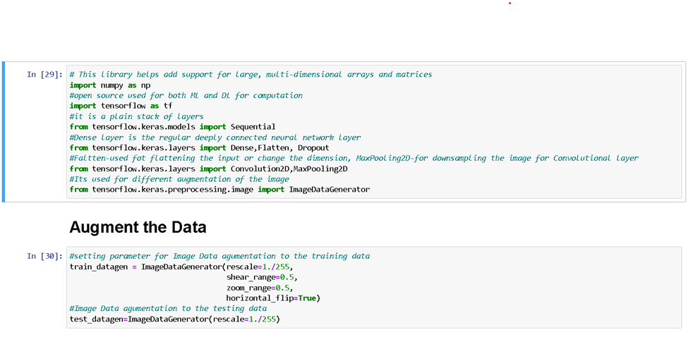

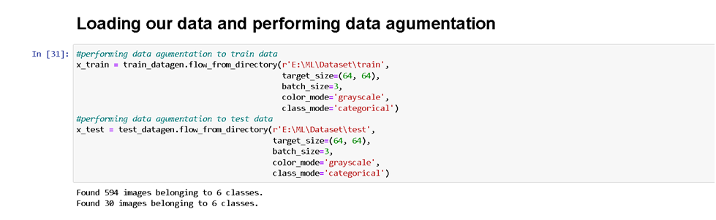

# Model Building

In this step we build Convolutional Neural Networking which contains a input layer along with the convolution, maxpooling and finally a output layer.

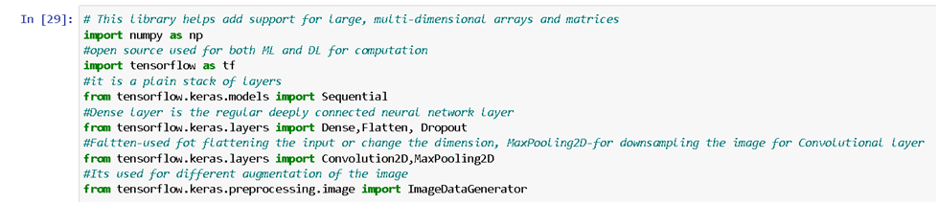

# Adding CNN Layers

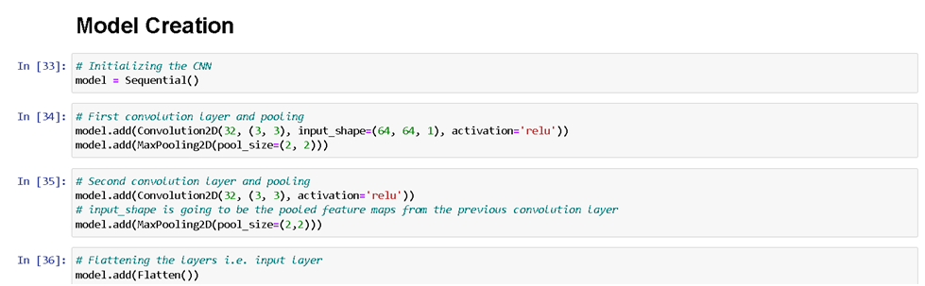

**Adding Dense Layers**

Dense layer is deeply connected neural network layer. It is most common and frequently used layer.

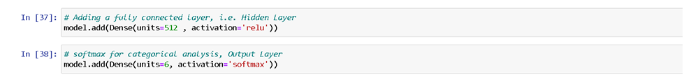

Understanding the model is very important phase to properly use it for training and prediction purposes. Keras provides a simple method, summary to get the full information about the model and its layers.

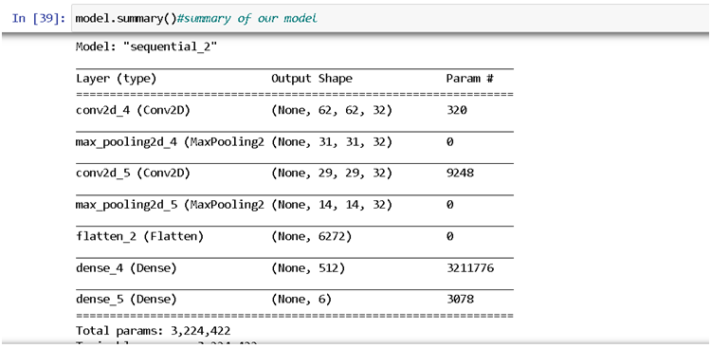

# Configure The Learning Process

1. The compilation is the final step in creating a model. Once the compilation is done, we can move on to training phase. Loss function is used to find error or deviation in the learning process. Keras requires loss function during model compilationprocess

* Optimization is an important process which optimize the input weights by comparing the prediction and the loss function. Here we are using Adamoptimizer

Metrics is used to evaluate the performance of your model. It is similar to loss function, but not used in training process

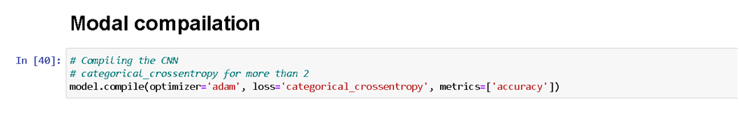

# Train The Model

Train the model with our image dataset.

**fit_generator**functions used to train a deep learning neural network

# Arguments:

1. steps_per_epoch : it specifies the total number of steps taken from the generator as soon as one epoch is finished and next epoch has started. We can calculate the value of steps_per_epoch as the total number of samples in your dataset divided by the batchsize.
2. Epochs : an integer and number of epochs we want to train our modelfor.
3. validation_data can beeither:
4. an inputs and targetslist
5. agenerator
6. an inputs, targets, and sample_weights list which can be used to evaluate the loss and metrics for any model after any epoch hasended.
7. validation_steps :only if the validation_data is a generator then only this argument can be used. It specifies the total number of steps taken from the generator before it is stopped at every epoch and its value is calculated as the total number of validation data points in your dataset divided by the validation batchsize.

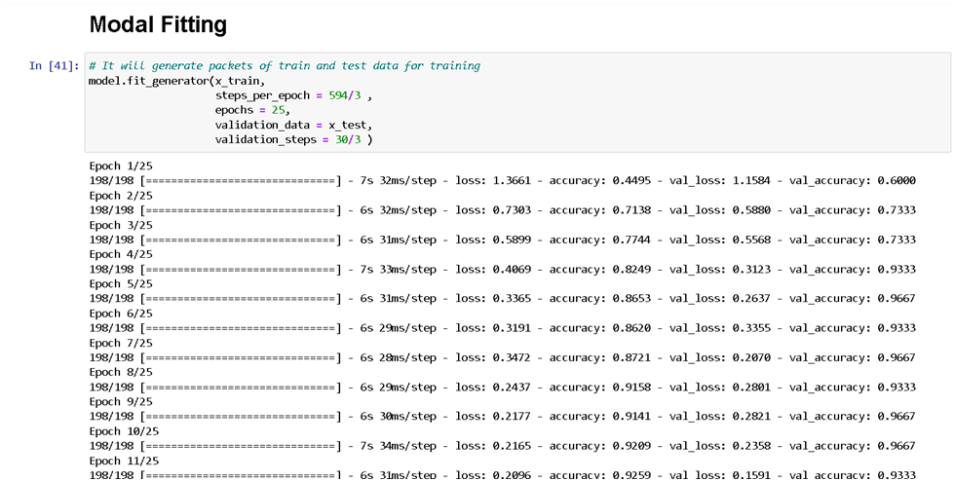

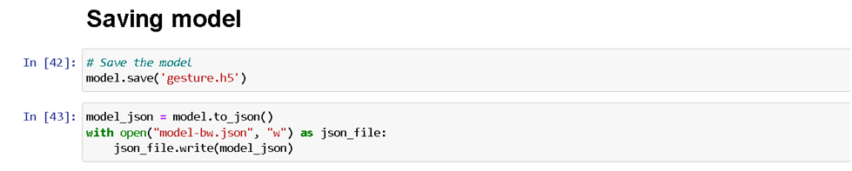

# Test The Model

Evaluation is a process during development of the model to check whether the model is best fit for the given problem and corresponding data.

Load the saved model using load_model

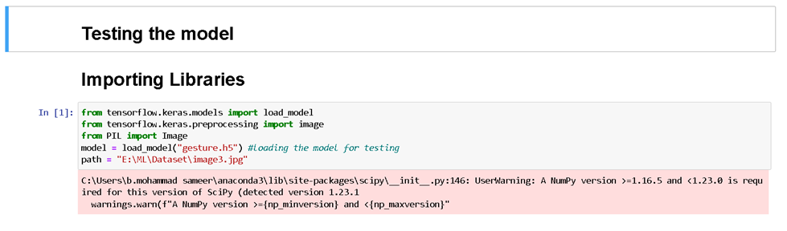

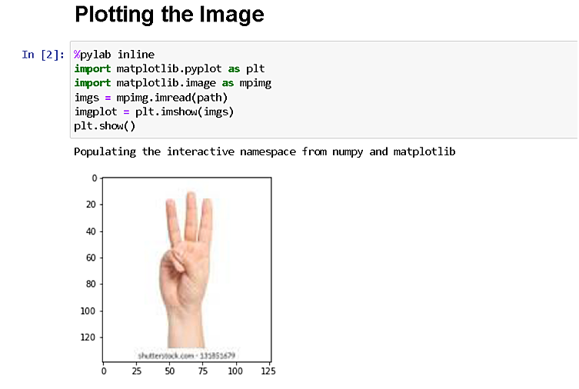

Taking an image as input and checking the results

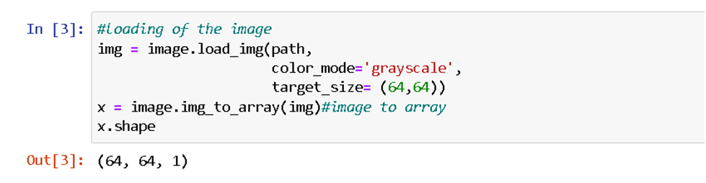

By using the model we are predicting the output for the given input image

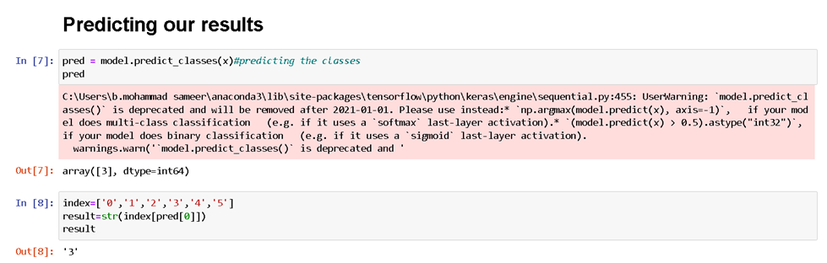

The predicted class index name will be printed here.

# Application Building

After the model is trained in this particular step, we will be building our flask application which will be running in our local browser with a user interface.

# Create HTML Pages

1. We use HTML to create the front end part of the webpage.
2. Here, we created 3 html pages- home.html, intro.html andindex6.html
3. home.html displays homepage.
4. Intro.html displays introduction about the hand gesturerecognition
5. index6.html accepts input from the user and predicts thevalues.

We also use JavaScript-main.js and CSS-main.css to enhance our functionality and view of HTMLpages.

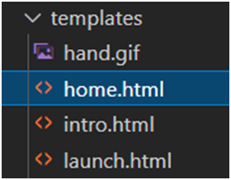

# Build Python Code

* Build flask file ‘app.py’ which is a web framework written in python for server-sidescripting.
* App starts running when “ name ” constructor is called inmain.

* render_template is used to return htmlfile.
* “GET” method is used to take input from theuser.
* “POST” method is used to display the output to theuser.
* ImportingLibraries

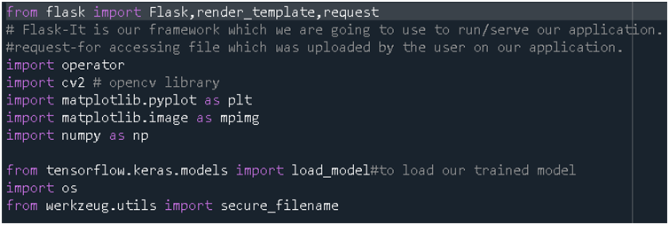

* Creating our flask application and loading ourmodel

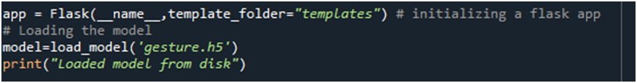

Routing to the html Page

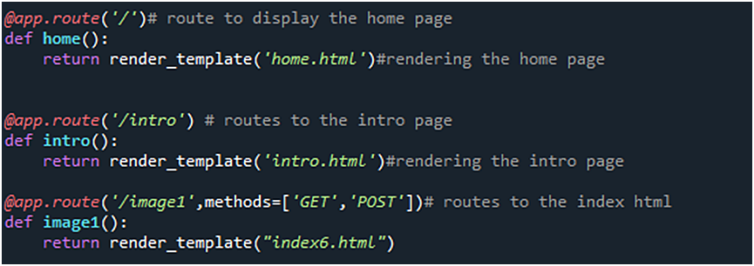

The above three route are used to render the home, introduction and the index html pages.



And the predict route is used for prediction and it contains all the codes which are used for predicting our results.

Firstly, inside launch function we are having the following things:

1. Getting our input and storingit
2. Grab the frames from the webcam.
3. CreatingROI
4. Predicting ourresults
5. Showcase the results with the help ofopencv
6. Finally run theapplication

# Getting our input and storing it

Once the predict route is called, we will check whether the method is POST or not if is POST then we will request the image files and with the help of os function we will be storing the image in the uploads folder in our local system.

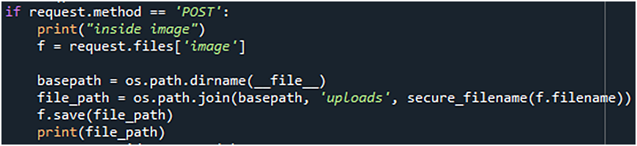

# Grab the frames from the web cam

# when we run the code a web cam will be opening to take the gesture input so we will be capturing the frames of the gesture for predicting our results.

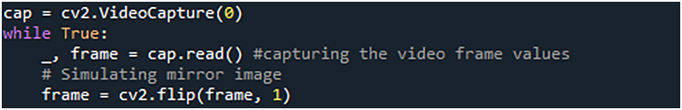

# Creating ROI

A region of interest (ROI) is a portion of an image that you want to filter or operate on in some way. The toolbox supports a set of ROI objects that you can use to create ROIs of many shapes, such circles, ellipses, polygons, rectangles, and hand-drawn shapes. A common use of an ROI is to create a binary mask image.

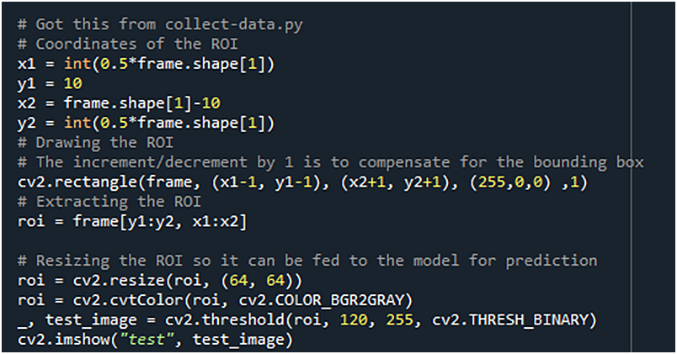

# Predicting our results

After placing the ROI and getting the frames from the web cam now its time to predict the gesture result using the model which we trained and stored it into a variable for the further operations.

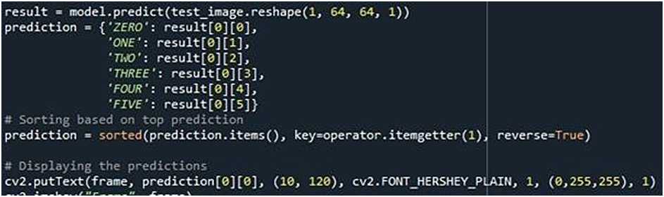

Finally according to the result predicted with our model we will be performing certain operations like resize, blur , rotate etc.

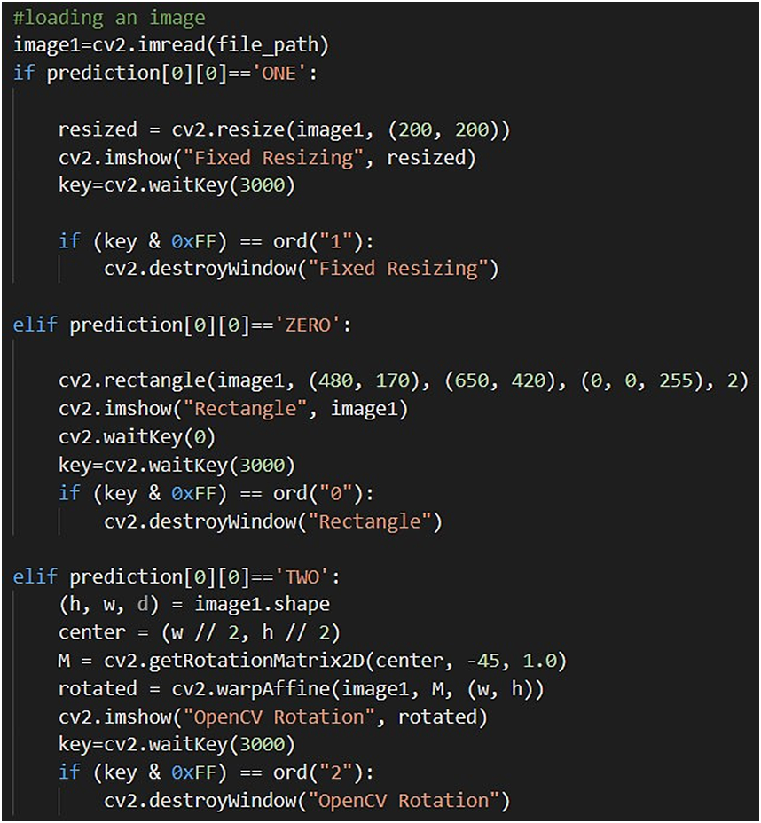

# Predicting our results

After placing the ROI and getting the frames from the web cam now its time to predict the gesture result using the model which we trained and stored it into a variable for the further operations.

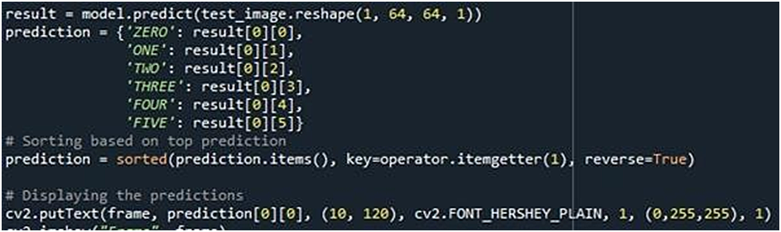

Finally according to the result predicted with our model we will be performing certain operations like resize, blur , rotate etc.

